**12-4 notes**

PyMongo and Advanced Queries

Goals:

* Use the PyMongo library to interface with MongoDB and perform basic CRUD operations.
* Select specific fields when retrieving documents from MongoDB.
* Use comparison operators to find documents in MongoDB.
* Use sort and limit with PyMongo when retrieving documents from MongoDB.

PyMongo is a library that allows interaction with a MongoDB database through Python. It is a native driver for MongoDB.

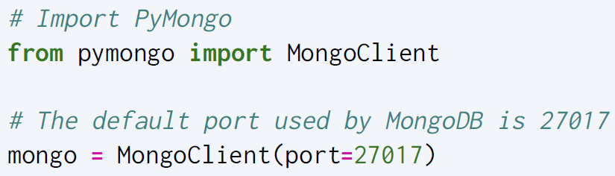

^ Establish a connection to the server.

ALWAYS MAKE SURE THE SERVER IS UP AND RUNNING FIRST (open Mongo Compass and connect)

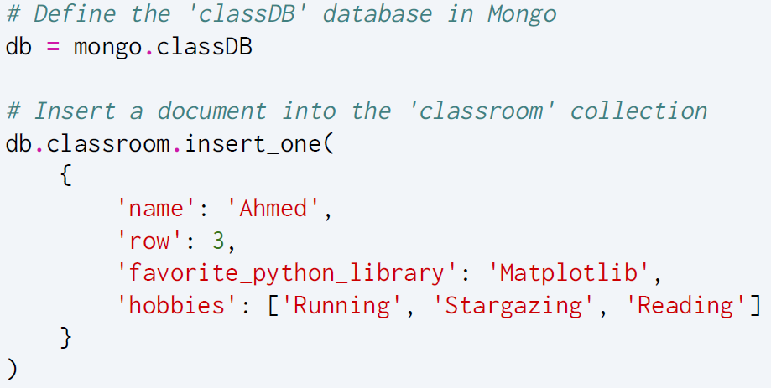

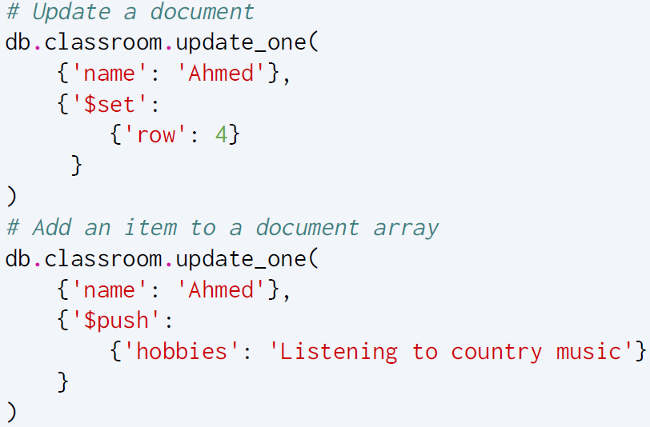

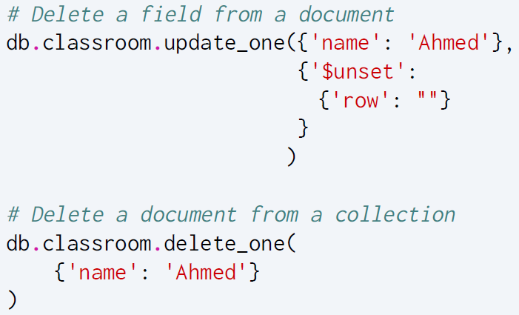

Set vs push for updating- Set is for one record at a time, whereas Push can be used for many at once.

Unset- used to remove a field from a record.

**Mongo Grove Solution:**

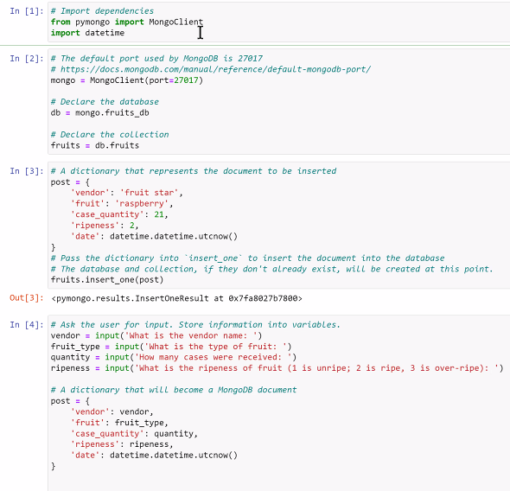

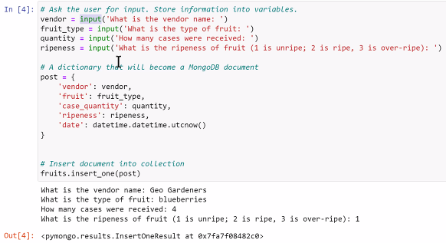

^ IN [2] makes both the database and a collection.

**Intro to Mongo Solution:**

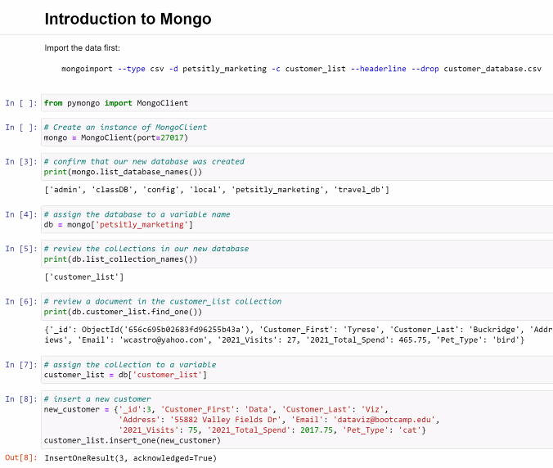

**Selecting Fields Solution:**

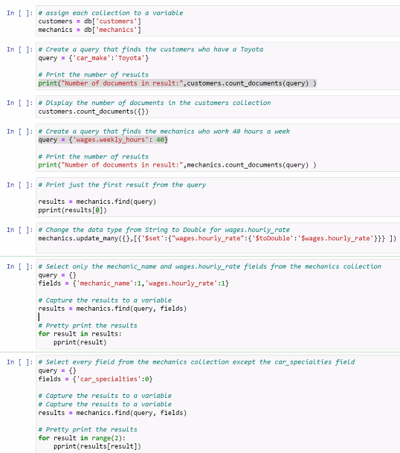

**Air Fields Solution:**

